**FLOWCHART:**

• Flowchart A graphical representation of the logic for the problem solving.

• The purpose of the flowchart is making the logic of the program in a visual

representation

• Flowcharts is a diagram made up of boxes, diamonds, and other shapes, connected

by arrows.

• Each shape represents a step-in process and arrows show the order in which they occur.

OVAL – TERMINAL SYMBOL

Parallelogram - Input/ Output symbol

Rectangle - Process symbol

Diamond - Decision symbol

Arrow lines - Flow lines

To represent a function

Circle – Connector

**TOOLS USED TO DRAW FLOWCHART**

**1. Smart Draw –** A good tool to draw and understand but can’t save the file in system it

can be used for free up to 7 days after that we must pay to use it.

**2. Canva –** A user-friendly tool which allows the user to view in mobile using the

application and can be saved in any format. Without even subscription all the

features were available.

**3. App.Diagrams.net -** The diagrams can be saved and also at any destination you want

it to be. But the Output Wasn’t precise and not in single page the saved diagrams

open up to the website.

**4. Lucidchart -** The diagrams can be directly stored into the system and has all the

features and also easy to use. It is required to be paid after some uses .

**5. Visme –** The tool is used for flowchart animation and content creating and in

teaching, but more tools are available when you pay for them.

**6. Zenflowchart –** The diagrams can be directly stored into the system and has all the

features and also easy to use. But it restricts to use more than 20 shapes on using the

21st shape it must be paid.

**7. Visual Paradiagram –** Visual paradiagram is explicitly designed for flowchart

drawing, it is also paid one to use but in complex algorithm cases it is the best

8. **Creatly –** This tool is used to design Unified Modeling Language (UML) and

flowcharts.

9. **Google Draw –** All the features are available and they are directly stored in the

Google Drive. It should be logged in using Email. But the page size was limited also

typing the algorithm wasn’t comfortable.

**FLOWCHART DEFINITION**:

Flowchart is defined as the graphical representation of the logic for the given problem.

**SYMBOLS USED IN FLOWCHART**:

(i) = Flowlines

(ii) = Start/Stop (Terminates)

(iii) = Input/Output

(iv) = Process symbol

(v)

= Selection

(vi) = Connector

(vii) = Funtion

EXP NO: 1-A

DATE: 29/11/22

**STUDENT GRADE ANALISIS**

**AIM**:

To draw flowchart and write algorithm for the following problem.

**ALGORITHM:**

Step 1: Start

Step 2: Get score

Step 3: If condition 0<=score<=100 is true go to step4, else go to

Previous step.

Step 4: If condition score>=80 is true “A” grade, else go to step5.

Step 5: If condition score>=60 is true “B” grade , else go to step6.

Step 6: If condition score>=50 is true “C” grade, else go to step7.

Step 7: print “FAIL”.

Step 8: Stop

**FLOWCHART:**

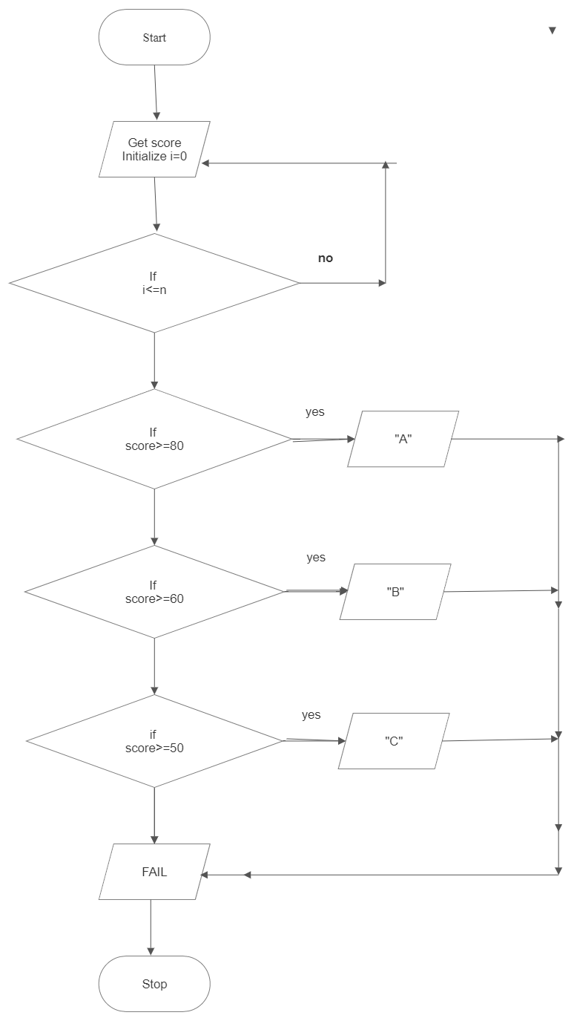

**PSEUDOCODE:**

BEGIN

GET score

IF 0<=score<=100 is TRUE

CHECK score>=80 is TRUE

PRINT “A” grade

ELSE

CHECK score>=60 is TRUE

PRINT “B” grade

ELSE

CHECK score>=50 is TRUE

PRINT “C” grade

ELSE

PRINT “FAIL”

END

**RESULT:**

Thus the algorithm and flowchart is successfully written for the given problem.

EXP.NO:1-B

DATE: 29/11/22

**CALCULATE ELECTRICITY**

**BILL**

**AIM:**

To draw flowchart and algorithm for the following problem.

**ALGORITHM:**

Step 1: Start

Step 2: Read units and note time of the day

Step 3: Calculate used units, this is differentiate between current units and previous units

Step 4: If condition1 is true EB BILL= used units*2,

Else go to Step5.

Step 5: If condition2 is true EB BILL= used units*5, else go to Step6.

Step 6: Display EB BILL=used units*3.5

Step 7: Stop

**FLOWCHART:**

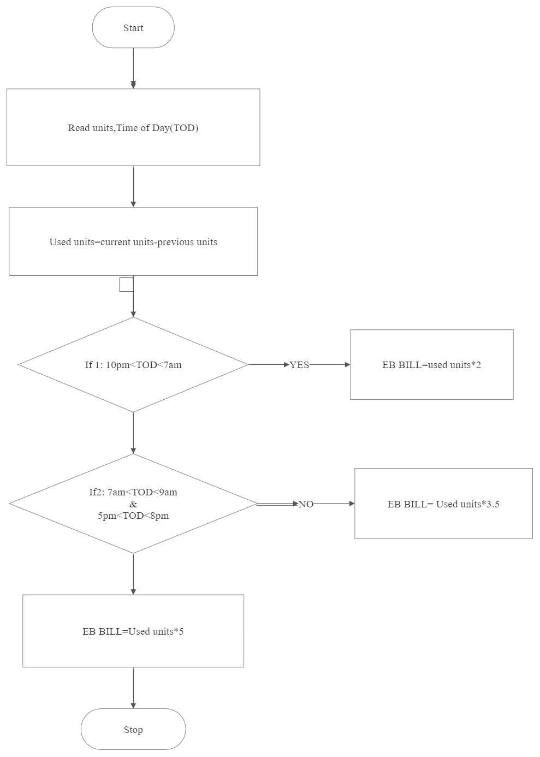

**PSEUDOCODE:**

BEGIN

READ units, timing

GET used units

IF 10pm<TOD<7am is TRUE

CALCULATE “EB BILL=used units*2”

ELSE

IF 7AM <TOD<9AM, 5am<TOD<8pm is TRUE

CALCULATE “EB BILL=used units*5”

ELSE

DISPLAY “EB BILL=used units*3.5”

END

**RESULT:**

Thus the algorithm and flowchart is successfully written for the given problem.

EXP.NO:1-C

DATE:29/11/22

**CALCULATE WEIGHT OF**

**IRON ROD**

**AIM:**

To draw flowchart and write algorithm for the following

problem.

**ALGORITHM:**

Step1: start

Step2: get the no of iron rods required as “n”.

Step3: Initialize i=0 and total=0.

Step4: Check if the value of i is less than n.

4.1: If the condition is true, get the diameter (D) of the rod.

4.1.1: Calculate unit weight using formula D**2/162

4.1.2: Get the number of rods with diameter D

4.1.3: Calculate weight of rod using formula No. of

rod*D*unit weight

4.1.4: Add this weight to total.

4.1.5: Increment Value of i by 1.

4.2: If condition is False, Display total as total weight of rod

Step 5: Stop.

**FLOWCHART:**

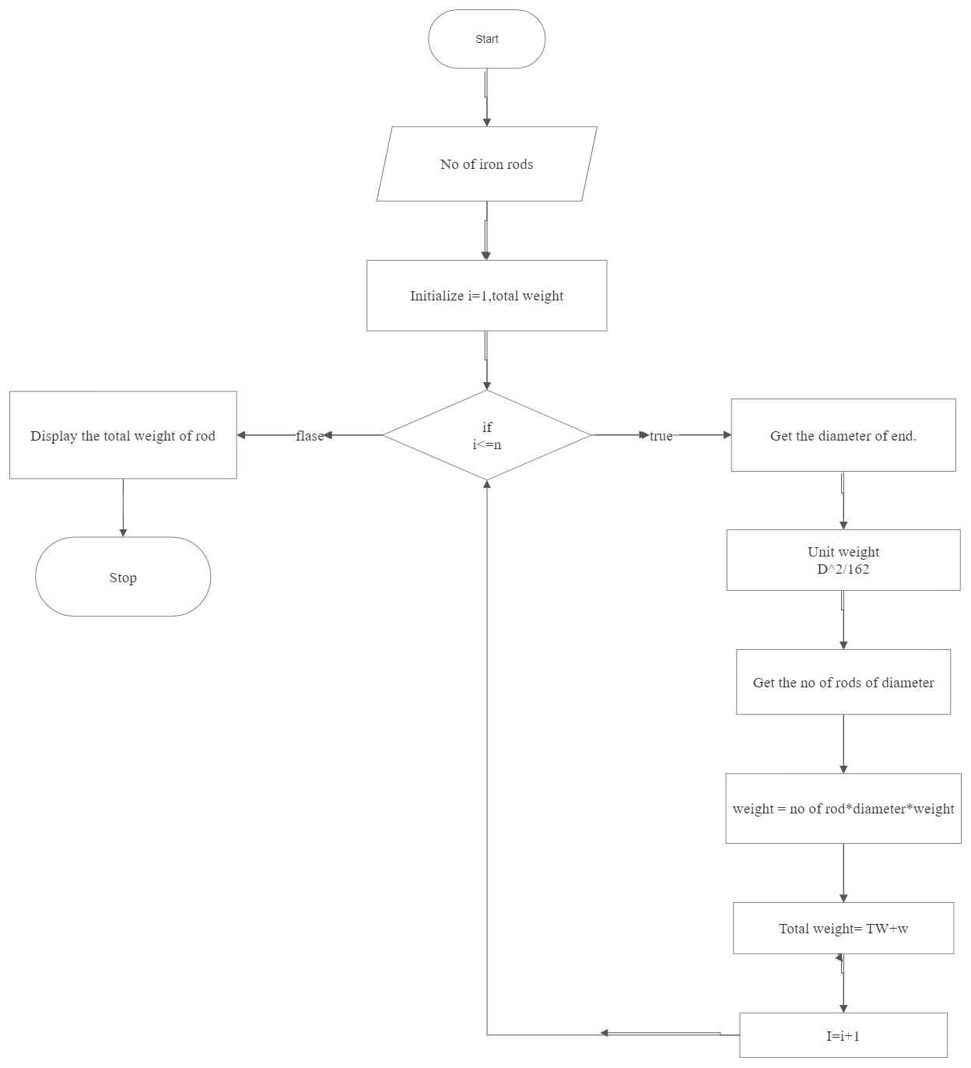

**PSEUDOCODE:**

START

GET no of iron rods(n)

INITIALIZE i=0 and total=0

CHECK IF i< n is TRUE

GET diameter(D) of the rod

GET no of rod with diameter

CALCULATE unit weight=D**2/162

CALCULATE weight of rod= no of rods* D* unit weight

ADD this weight to total

INCRETMENT i

ELSE

DISPLAY total=total weight of rod

STOP

**RESULT:**

Thus the algorithm and flowchart is successfully written for the given problem.

EXPT.NO:1-D

DATE:29/11/22

**CALCULATING WEIGHT OF MOTOR BIKE**

**AIM:**

To draw flowchart and write algorithm for the following problem.

**ALGORITHM:**

Step1: start

Step2: Get the gross vehicle weight of rating (GVWR)

Step3: Get dry weight (DW),

Get fuel weight (FW),

Get rider weight (RW),

Get passenger weight (PW)

Step4: Calculate total weight for the given formula

TW=DW+FW+RW+PW

Step5: Get load and calculate load.

5.1.1: calculate load weight (LW) = TW + load

5.1.2: calculate safe weight (SW) = GVWR-load weight

Step6: If condition SW>=0 is true you are ready for a safe

Journey.

Else go to step7.

Step7: you are requested to reduce the weight.

Step8: Stop.

**FLOWCHART:**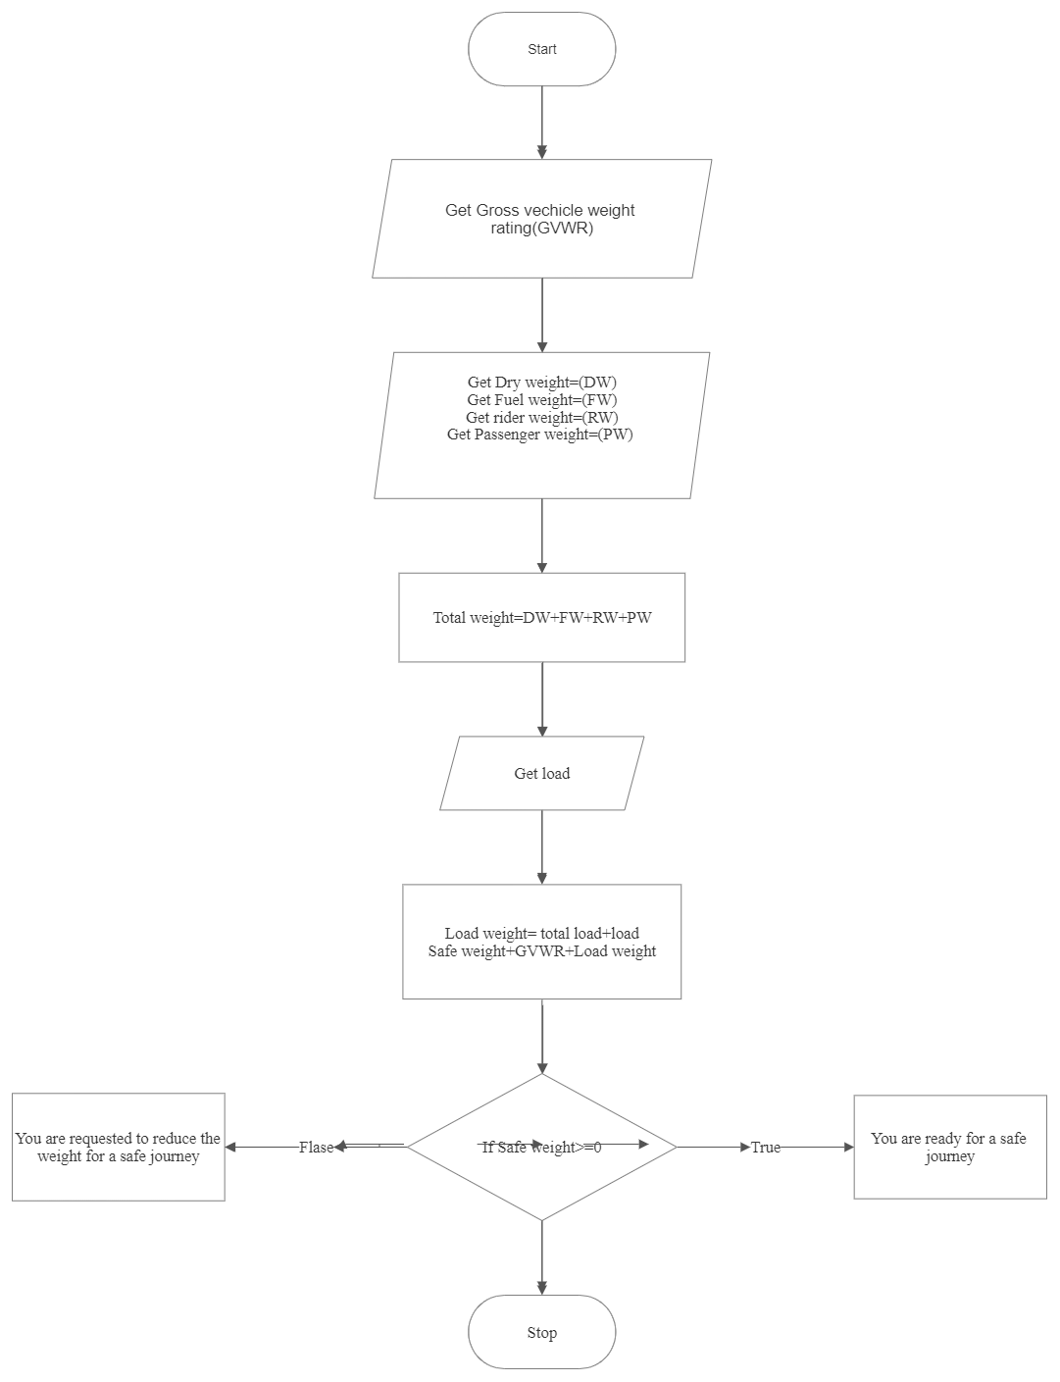

**PSEUDOCODE:**

BEGIN

GET the gross vehicle weight rating (GVWR)

GET dry weight (DW), fuel weight (FW), rider weight (RW), passenger weight (PW)

CALCULATE total weight = DW+FW+RW+PW

GET load

CALCULATE load weight = total weight + load

CALCULATE safe weight = GVWR – load weight

IF safe weight>=0 is TRUE

DISPLAY “you are ready for safe journey”

ELSE

DISPLAY “you are requested to reduce the weight for a safe journey”

END

**RESULT:**

Thus the algorithm and flowchart is written for the given

Problem.

EXPT.NO:1-E

DATE:29/11/22

**CALCULATE** **RETAIL SHOP BILL**

**AIM:**

**To** draw flowchart and write algorithm for the given problem.

**ALGORITHM:**

Step1: Start

Step2: Get the value Bill no and Bill date.

Step3: Get the details for customers: (Name, Address, Mobile no).

Step4: Get the no of items purchased as n

Step5: Initialize i=0, total=0.

Step6: Check condition i<=n:

6.1: If True get item details like name, price, count, discount.

6.1.1: Calculate subtotal = no of items * unit price

6.1.2: Calculate discount total= subtotal * discount/100

6.1.3: Calculate total= total+ discount total

6.1.3: Increment the value of i by 1.

6.2: If condition is False, Get the value of GST.

Step7: Stop.

**FLOWCHART:** 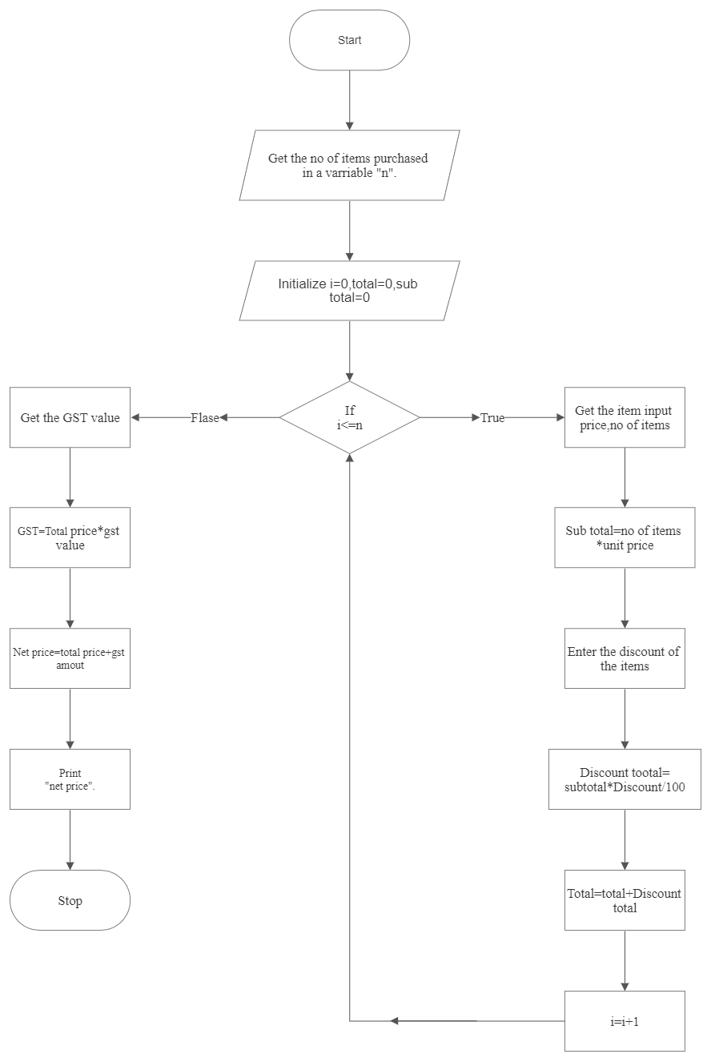

**PSEUDOCODE:**

BEGIN

GET bill no, bill date

GET customer name, address, ph no

GET no of item purchased (n)

INITIALIZE i=0, total=0

IF i<=n is TRUE

GET item details (name, price, amount, discount)

CALCULATE subtotal = no of items *unit price

CALCULATE discount total = subtotal*discount/100

CALCULATE total= total + discount total

INCREMENT the value of i by 1

ELSE

GET Gst value, CALCULATE Gst value= total price* Gst value

CALCULATE net price= total price + Gst

PRINT net price

END

**RESULT:**

Thus the algorithm and flowchart is written for the given problem.

EXPT.NO:1-F

DATE:29/11/22

**CALCULATE SINE SERIES**

**AIM:**

To draw the flowchart and write algorithm for the given problem.

**ALGORITHM:**

Step1: Start

Step2: Get the value of X

Step3: Initialize the value of i =1, sine =0 and import math.

Step4: Get the value of N

Step5: check the value of i is less then N:

5.1: If the condition is true, convert X to radian and adding it to y

5.1.1: let the value of s be (-1) to the power i

5.1.2: Now calculate sine series using formula:

Sine= sine + ((y**2*i+1))/math. factorial(2*i+1) *S

5.1.3: Increment value of I by 1

5.2: If condition is false, display sine.

Step6: Stop.

**FLOWCHART:**

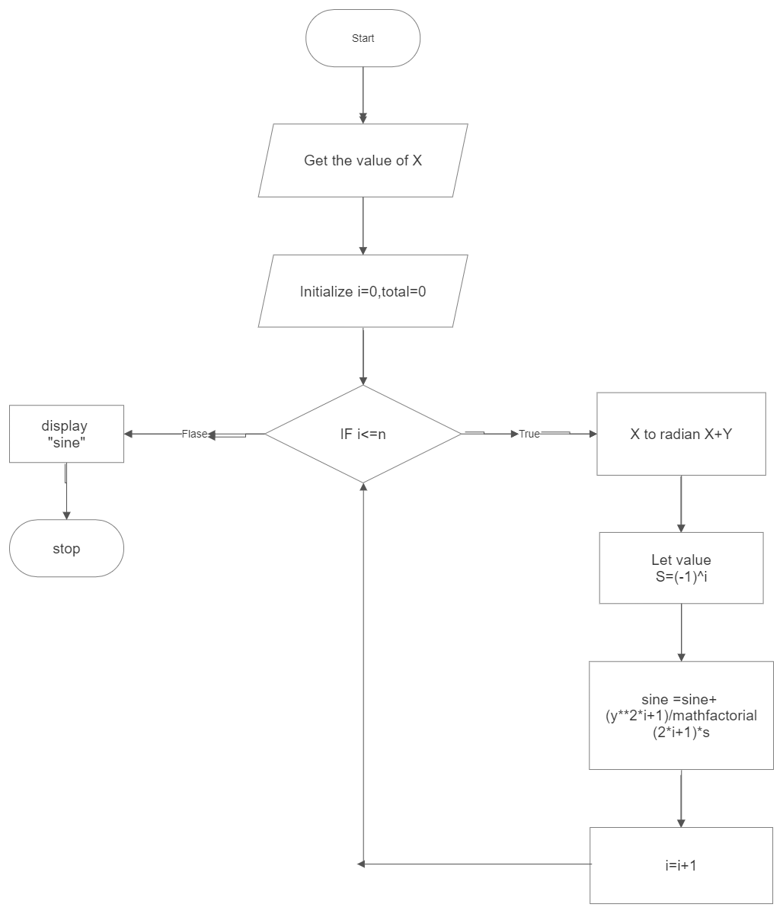

.

**PSEUDOCODE:**

BEGIN

INITIALIZE i=0, total=0

GET the value of X

IF i<=n is TRUE

X to radian X+Y

LET value S = (-1) ** i

CALCULATE sine =sine+(y**2*i+1)/math fact(2*i+1) *s

INCREMANT the value of i by 1

ELSE

DISPLAY “sine”

END.

**RESULT:**

Thus the flowchart and algorithm is written for the given problem

EXPT.NO:1-G

DATE:29/11/22

**ELECTRICAL CURRENT IN 3 PHASE AC**

**AIM:**

To draw flowchart and write algorithm for the given problem.

**ALGORITHM:**

Step1: Start

Step2: Read the value of pf, I and V.

Step3: calculate by using formula P=V3*pf*I*V

Step4: Display the result is “p”.

Step5: Stop

.

**FLOWCHART:**

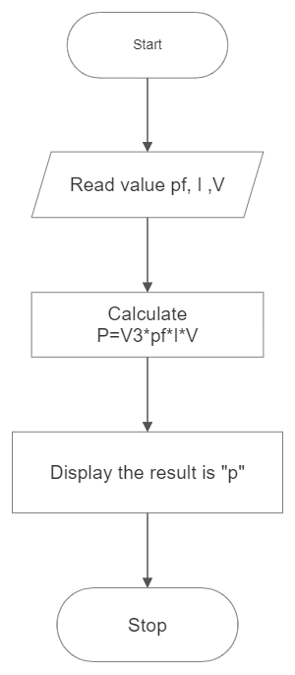

**PSEUDOCODE:**

BEGIN

READ pf, I, V

CALCULATE P=V3* pf* I* V

DISPLAY “P”

END

**RESULT:**

Thus the algorithm and flowchart is written fo the given problem.